Yoga Retreat in Aumale, Northern France
Friday 10th- Monday 13th September 2021.
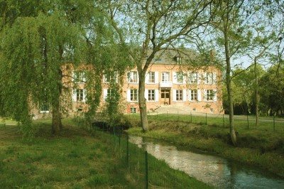

The Retreat
‘‘A weekend get-away of Yoga, Mindfulness and Relaxation in a beautiful setting providing the chance to find space and reset, take a break from the day- to- day and explore new ways of being.
Two Yoga/Mindfulness practices will be held daily exploring body and mind connection. Hatha Yoga classes to energise in the morning and relaxing evening classes, including Meditation and breathing practice. A nurturing and safe environment to relax and explore new ways of being and experienced teachers to provide support and help development and transformation.

You'll leave not only feeling refreshed and energised, but with new coping mechanisms in your tool kit, mindfulness techniques you can use going forward and new friends and connections’’.

Location and Residence

The beautiful, peaceful Mill Retreat Centre was originally built in 1846 as a Camembert cheese factory and is in a spectacular setting with other 30 acres of grounds. These include a 10-acre lake, with stunning wetlands, habitat and over a mile of riverbanks, perfect for relaxing, walks and wildlife spotting. With a 6-acre poplar wood plantation and wide variety of native plants and trees. The grounds of the Mill are a paradise for a huge variety of creatures including wild boar and deer, to water mammals such as otters and over 40 species of birds.

Accommodation and prices & transport
All prices include:
- 3 nights’ accommodation (Fri, Sat & Sunday). Exclusive use.
- All food and refreshments (locally sourced where possible, cooked by the Mill’s amazing, dedicated Chef)
- Energising Morning Yoga practice, aprox. 8am.
- A beautiful evening meditation and restorative practice, aprox. 4.30pm.
- An optional breathing practice
- Bicycles and a boat are also available for you to use at your leisure.
- Ample free time in the day to rest and recharge in the Stunning Mill house.
All-inclusive price for the weekend £485.
The price does not include transportation however there are many different options, the easiest being Eurotunnel to Calais.
A minibus from Calais to the Mill Retreat is available (1.5hours). The cost is £65pp (return) if there are 10 or more passengers. This is on a first come, first served basis as spaces are limited. Or of course you could always bring your own car as there is ample secure parking on-site.
There are a few other transport options including flying, please contact me for more details.
Your Teacher
Amanda Turner has been teaching hatha yoga for four years after falling in love with this discipline 8 years ago. She is passionate about working with individuals, exploring what yoga can bring to ‘one’s entire well-being’, learning & unlearning, sharing together to find equilibrium, peace & exploration of the inner self.
For further details or bookings email; amanda@amandaturneryoga.co.uk or call 07795361533. £100 deposit required to secure place. Full payment by 1st July 2021.
