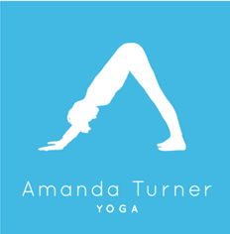

Online Streaming Classes, Times Via Zoom.

During the lockdown & phases of returning to life as we once knew it, all group classes virtually through Zoom.
The full time table & details can be access on http://instabook.io/s2/amandaturneryoga

Private classes: Great for extra attention to alignment & tailored to your needs. These can be enjoyed online or with social distancing measures outside during the summer months
- Daytime practice between 9.30am & 4.30pm – £50.00 per hour, £60 for 1 hour 15
- Evening or weekend - £80.00 per hour
- First Class must be 1:15 minutes due to consultation and level of content.
- (24 hours’ notice required for cancellation or will be charged at full price).
- Small group practice is charged per person, dependent on numbers.
- One to One private class are available outside, weather permitting under the government guidelines of social distancing.

Corporate Classes: Great for businesses to encourage balanced wellbeing within the workplace. Yoga classes can be personalised to suit the needs of a team regularly or as a ‘one off’ introduction.

Please call: 07795361533 or email amanda@amandaturneryoga.co.uk for further enquiries.
www.amandaturneryogo.co.uk
Instagram https://amanda_turneryoga
https://www.facebook.com/Amanda-Turner-Yoga-1583825405255278/

